Incident Report

13107 Offensive: User Log in

Date: 5-26-2022 (DS)

# Executive Summary:

ProsperSec was contacted by The Tech Academy to conduct penetration testing on a new Juice Shop application. The main goal was to see if a particular user (Bender) could be reached without needing a password.

**Results**:

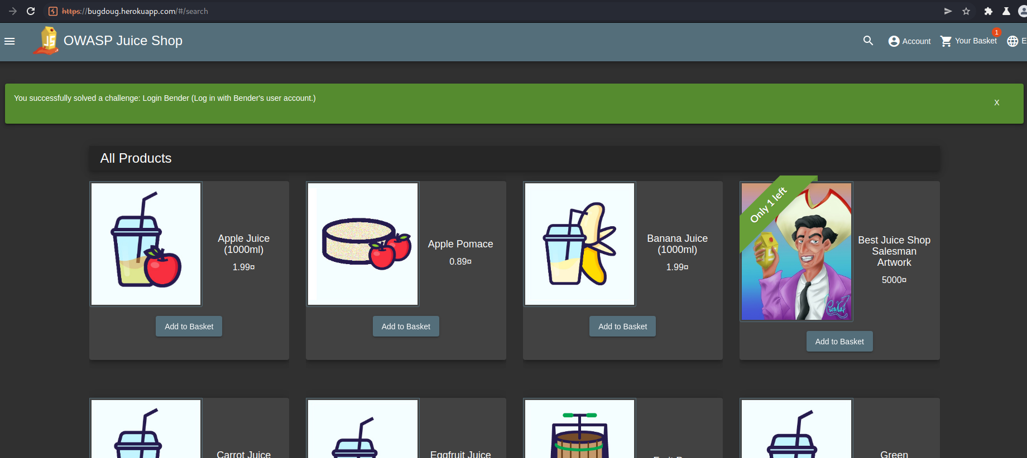

**Application Details:**

Application URL: bugdoug.herokuapp.com/#/login

User Account: bender@juice-sh.op

**Attack Narrative:**

Similar to the Admin vulnerability, I was able to comment out (‘ - -) Bender’s email, which allowed access to the account.

**Conclusion:**

ProsperSec was contracted to find vulnerabilities in the application, Juice store is unsafe due to a major breach in the all users account using a very simple injection. The result was I was able to get into the Benders account (along with everyone elses) and potentially access more information or hold the application for ransom.

_____________________________________________________________________________________